**DAILY ONLINE ACTIVITIES SUMMARY**

|  |  |  |  |  |  |  |  |  |
| --- | --- | --- | --- | --- | --- | --- | --- | --- |
| **Date:** | **03/06/2020** | | | | | **Name:** | **Hanan Saleem Baji** | |
| **Sem & Sec** | **4th SEM 'A' Section** | | | | | **USN:** | **4AL18CS024** | |
| **Online Test Summary** | | | | | | | | |
| **Subject** | | **Object Oriented Concept** | | | | | | |
| **Max. Marks** | | **30** | | **Score** | | | **15** | |
| **Certification Course Summary** | | | | | | | | |
| **Course** | **1. Cyber security** | | | | | | | |
| **Certificate Provider** | | | **1. Great Learning Academy** | | **Duration** | | | **1. 3 hour** |
| **Coding Challenges** | | | | | | | | |
| **Problem Statement:** 1. Write a code segment in java to swap two numbers using call by object reference.  2. Write a Java program to find Last Digit of a^b (a to the power b) for Large Numbers.  3. Write a function that takes a two-digit number and determines if it's the largest of two possible digit swaps.  .  For example | | | | | | | | |
| **Status: completed** | | | | | | | | |
| **Uploaded the report in Github** | | | | | **Yes** | | | |
| **If yes Repository name** | | | | | 1. <https://github.com/saleemhananbaji/C-coding> 2. <https://github.com/saleemhananbaji/Java-coding> | | | |
| **Uploaded the report in slack** | | | | | **Yes** | | | |

ONLINE TEST DETAILS: Online test was conducted on the second and third module of **Object Oriented Concept**. Test contains 30 questions of 1 mark each . I have scored 15 Marks.

Snapshot:

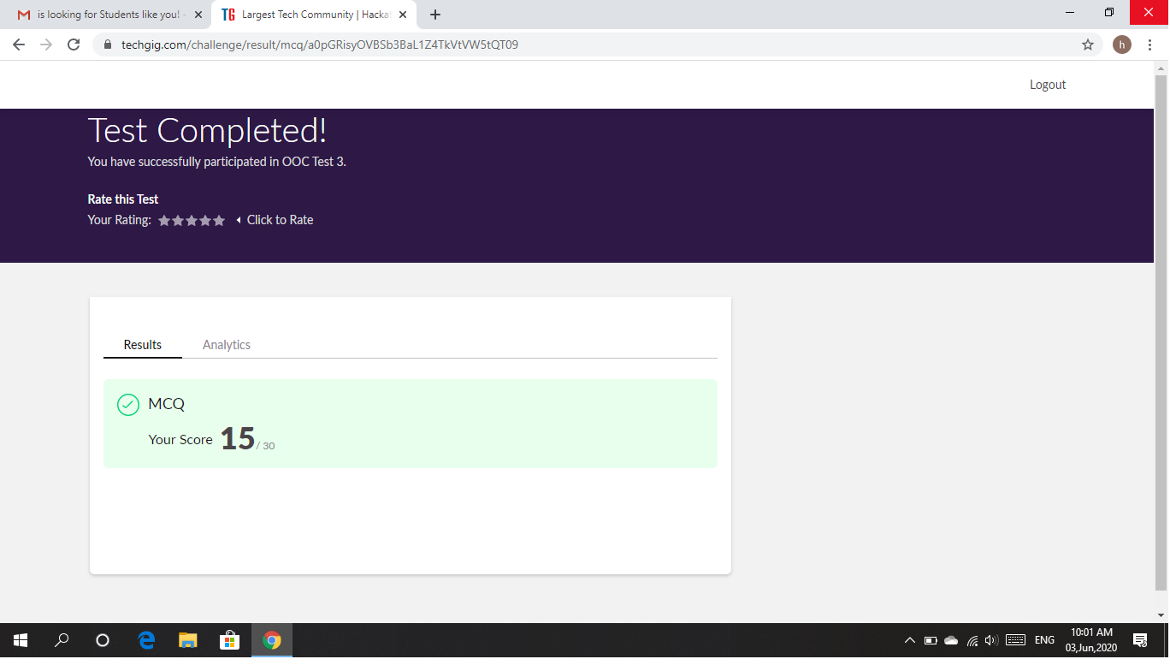

Certification Course Details: As the continuation of online course, I was able to complete the secure system design in cyber security.

Snapshot:

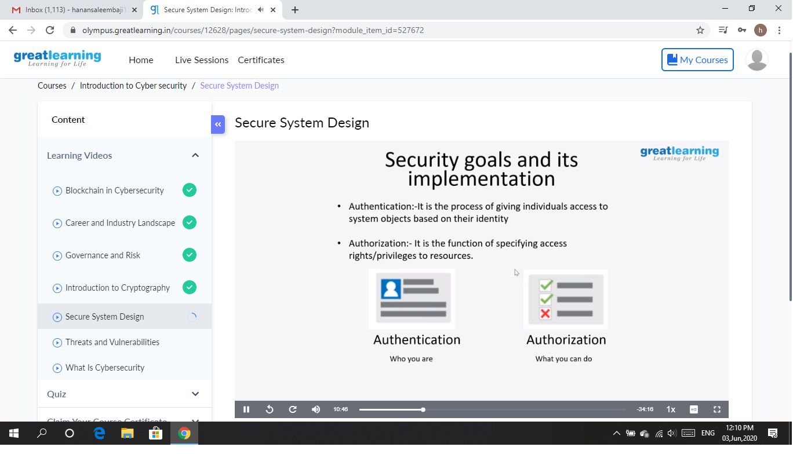

CODING CHALLENGES DETAILS: Problem statements

1. Write a code segment in java to swap two numbers using call by object reference.

Solution: Uploaded it in github

Snapshot:

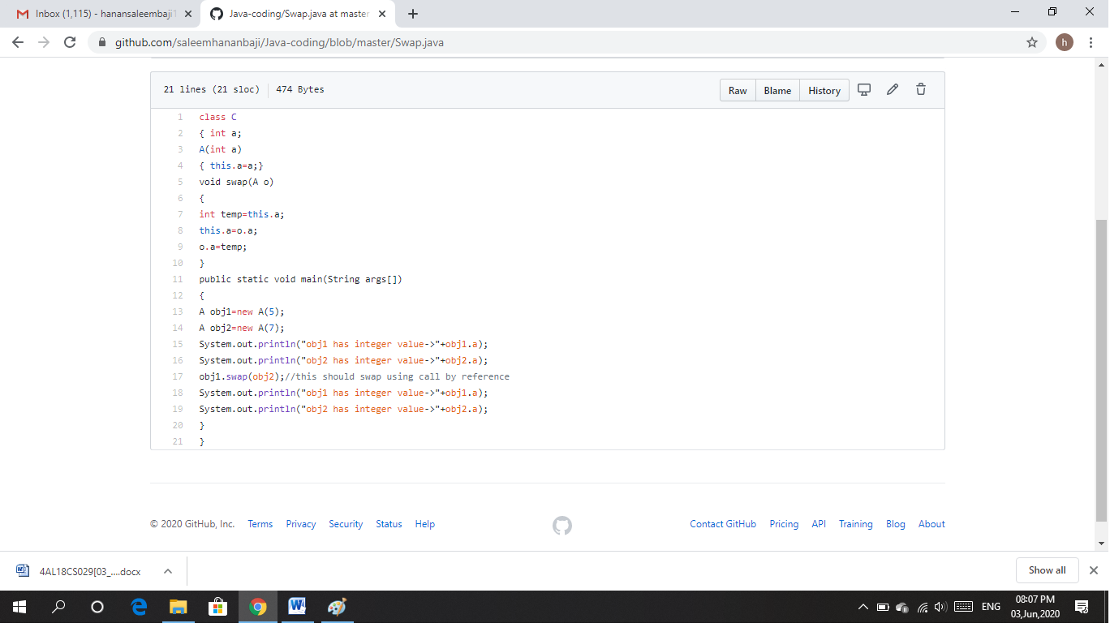

2. Write a Java program to find Last Digit of a^b (a to the power b) for Large Numbers.

Solution: Uploaded it in github

Snapshot:

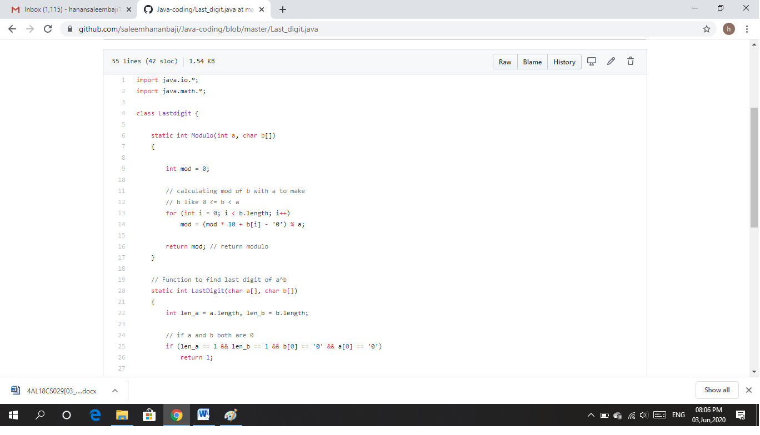

3. Write a function that takes a two-digit number and determines if it's the largest of two possible digit swaps.

Solution: Uploaded it in github

Snapshot:

